NA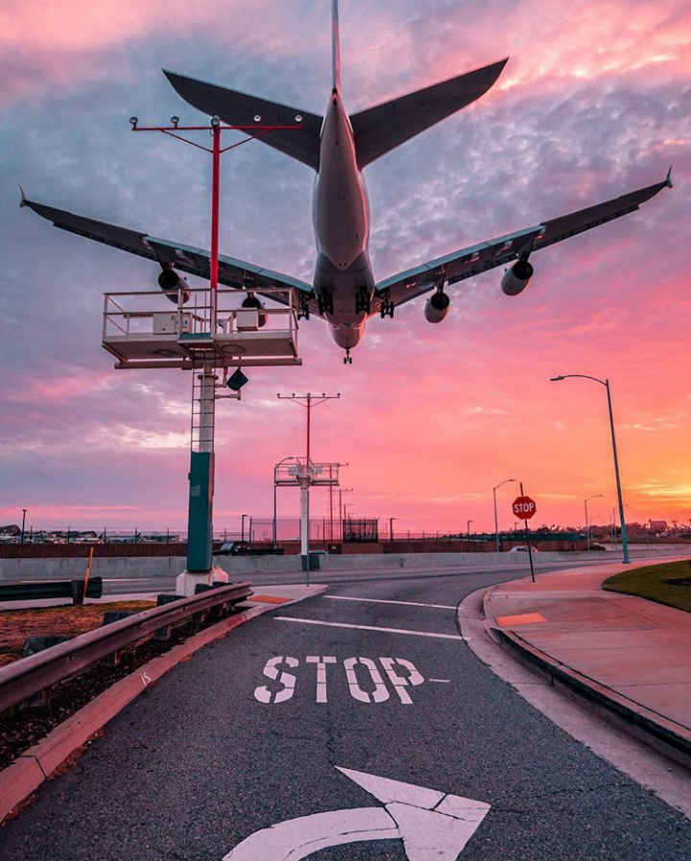

**AIRLINE**

**RESERVATION**

**IP PROJECT CLASS 12**

**INDEX**

**NAME –** TEGHPREET SINGH MAGO

**CLASS –** XII A1

**SUBJECT** – INFORMATICS PRACTICES

**TOPIC** – AIRLINE RESERVATION

|  |  |  |
| --- | --- | --- |
| **S.NO.** | **TOPIC** | **PAGE** |
|  | CERTIFICATE |  |
|  | ACKNOELEDGEMENT |  |
|  | OBJECTIVES OF THE PROJECT |  |
|  | INTRODUCTION |  |
|  | TABLE STRUCTURES |  |
|  | MENU OPTIONS |  |
|  | CODING AND OUTPUT FOR MYSQL |  |
|  | CSV TABLES |  |
|  | CODING AND OUTPUT FOR MENU IN PYTHON |  |

**CERTIFICATE**

This is to certify that Teghpreet Singh Mago, student of class XII has successfully completed the project on the topic ‘Airline Reservation’ under the guidance of Ms. Taruna Mongia (IP teacher) during the year 2020-21.

(Taruna Mongia)

Informatics Practices Teacher

**ACKNOWLEDGEMENT**

I would like to express my special thanks of gratitude to my teacher, Ms. Taruna Mongia who gave me the golden opportunity to do this wonderful project on the topic ‘Airline Reservation, which also helped me in doing a lot of research and I came to know about so many new things. I am really thankful to her.

I would also like to thank my partner, Teghpreet Singh Mago/ Vanshika Bhatnagar, who has helped me through all stages of the project, and has really been a great source of motivation and assistance.

Lastly, I would like to thank my parents for providing me with all the technical supplies and being so supportive.

**OBJECTIVES OF THE PROJECT**

**Some Main Objectives Of The PVR System Are As Below :**

* To Ease the tasks of the staff by computerization of the manual works
* To make the Airline Reservation System more customer friendly, by allowing timely and easy access to data
* To equip the system of Online Check-in with more options and easy access, making it more user and staff-friendly
* To prepare a structure database foe easy handling of The Airline Reservation System
* With highly efficient computerization of the system, paperwork will be eliminated.
* To integrate Passenger and Flight detail, by creating a third table TICKET.
* With efficient language platforms like Python and MySQL, Redundancy in maintaining data and unnecessary replication of data are eliminated.
* To ease the process of updating data and making changes to the existing data.
* To make Airline services 24x7 available.
* With an all round availability of passenger information, the Airport security could be harnessed, making detection of terrorists and unauthorised personnel easy.
* To prevent data inconsistency by running multiple checks to make sure data entered is correct.

**INTRODUCTION**

Today, internet has spread its tentacles through all the strata of our society. One cannot imagine his life without internet. We find the use of internet almost everywhere, from buying groceries online to ordering food to booking tickets online. All this has become so easy, just at the click of a mouse button. This project also talks about Airline Reservation system.

This project tries to computerise the functioning of Airline Reservation system. It takes care of handling customers’ reservation and maintaining records in various databases. One can book tickets as and when required, compare various flights at different times.

Through Airline Reservation, one can check flights for different destinations, check whether flight is on time or not, duration of flight etc. one can book tickets for themselves by entering details like name, address, phone number etc.

In this project, we have appointed the One table one menu format, wherein each table is assigned a specific type of menu depending upon the type of data it holds.

1) The first table, “Airline_Details” Table primarily deals with basic airline information that needs to be constantly updated. Hence, we have assigned the “Update” Menu which contains various options like add, delete, modify and update status of flights. This Table is the backbone of the airport system, as per our project.

2) The second table, “Passenger_Details” deals with majority of the passenger details such as Name, Address, Phone No., Email_ID, Gender, Nationality, etc. We have assigned the “Display” menu in order to present data according to various columns. It contains various options like to display data based on age, extracting all female records etc. This menu makes data more categorically sound and logically presentable, in report format.

3) The third table, “Ticket” table is an intersection of the above two tables, as it deals with flight as well as passenger details. We have assigned “Analysis” menu to this table as it displays the data in pictorial graph i.e. in the form of various graphs like pie chart, line chart, and bar chart. This menu makes the flight and passenger analysis easier, allowing the flight management to review its service.

**TABLE STRUCTURES**

TABLE1- AIRLINE DETAILS

|  |  |  |
| --- | --- | --- |
| Column Name | Constraints | Data Type |
| Airline_ID | Primary Key | varchar(6) |
| Airline_Name | Not Null | varchar(20) |
| Departure_Destination |  | varchar(20) |
| Departure |  | DateTime |
| Arrival_Destination |  | varchar(20) |
| Arrival |  | DateTime |
| Duration |  | int(2) |
| Total_Seats |  | int(2) |
| Status |  | varchar(10) |
|  |  |  |

TABLE2-PASSENGER DETAILS

|  |  |  |
| --- | --- | --- |
| Column Name | Constraints | Data Type |
| Airline_ID | ForeignKey | varchar(6) |
| Passenger_ID | Primary key | varchar(6) |
| Name | Not Null | varchar(15) |
| Address |  | varchar(30) |
| Phone_ Number | Not Null | integer(12) |
| Email |  | varchar(50) |
| Gender |  | varchar(6) |
| Nationality |  | varchar(15) |
| Age | check(age<60) | int(2) |
| Luggage_Count |  | int(2) |

TABLE3-TICKET

|  |  |  |
| --- | --- | --- |
| Column_Name | Constraints | Data Type |
| Airline_ID | Foreign key | varchar(6) |
| Ticket_No | Primary key | varchar(6) |
| Seat_No | Not Null | int(2) |
| Meal_Status |  | varchar(5) |
| Category | check(category in(economy or business or premium) | varchar(9) |
| Departure |  | DateTime |
| Arrival |  | DateTime |
| Departure_Destination | | varchar(20) |
| Arrival_Destination |  | varchar(20) |
| Luggage_count |  | int(2) |
| Gate | Not Null | int(2) |

**LIMITATIONS OF**

**THE PROJECT**

* **I could have designed it well and with better backgrounds and amazing color combinations.**
* **I could have used the most recent versions of the technical platforms I have used.**
* **I also have not used any radio button or check box in my project.**
* **I could have done a little better.**

**MENU**

**Table1**

1. To add a record
2. To delete a record
3. To modify a record
4. To display records order by destination
5. To display records with number of seats greater than 100

**Table2**

1. To display data order by age
2. To display all female records
3. To count all passengers having luggage_count>2
4. To display name, phone_number group by nationality
5. To display records of passengers with no luggage
6. To calculate maximum, minimum and average age, group by gender

**Table3**

1. Vertical Bar chart-Total seats versus Airline_ID
2. Horizontal Bar Chart- Luggage_Count versus Airline_ID
3. Pie Chart-Meal_Status versus No. of passengers
4. Pie Chart-Category versus no. of passengers
5. Histogram of no. of passengers in each age category